**Jenkins Integration with GIT:**

* Add your source code to Git hub.
* Then go to Manage Jenkins🡪manage plugins 🡪 available🡪 find git plugin and then download and install it .
* Now go to project 🡪 configure

Now you can see the git option under source code management as shown below:

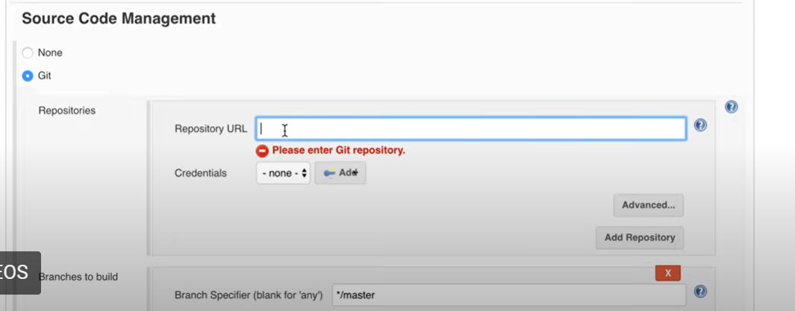

Here under Repositoru URL give the URL of git hub where that project code is present.

Now in Build triggers select poll SCM so that SCM can be polled for any new changes in the code.

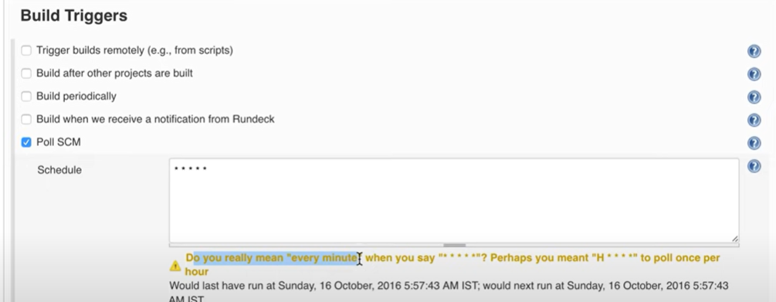

Now save and apply the changes.

Now if there is any change in the source code then the build will get triggered automatically.